# How to create Azure Logic apps and deploy using Azure DevOps

This Article gives you an overview of

How to create Azure Logic apps and deploy using Azure DevOps

Steps:

## Create a Logic App using Visual Studio

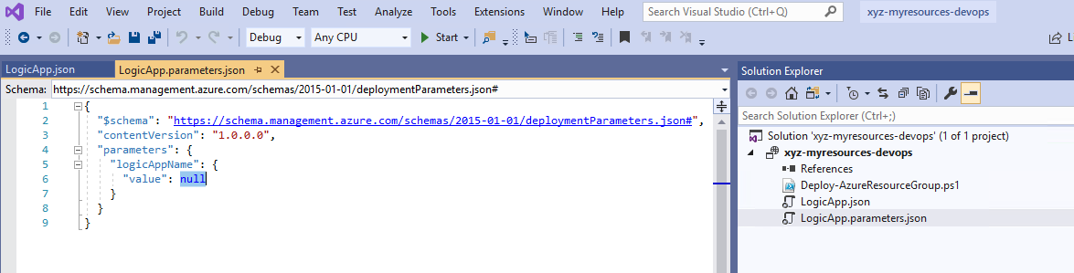

## Checked in Source Code to GitHub

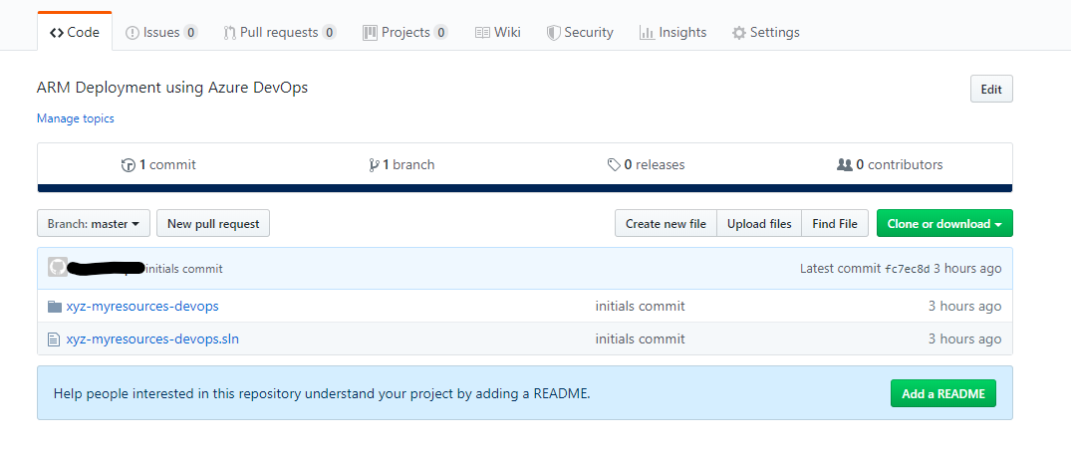

## Create one new project in [https://dev.azure.com](https://dev.azure.com/)

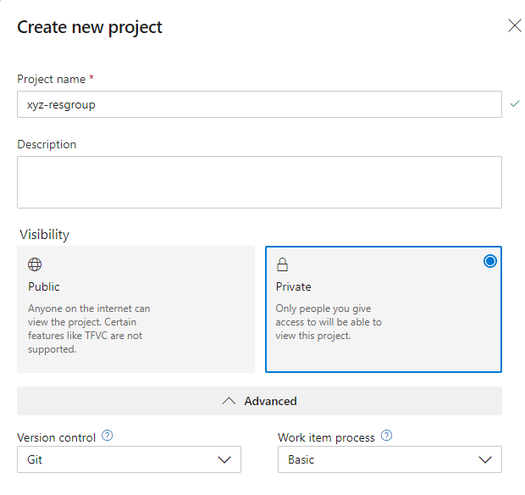

Create Build and Release pipeline for Azure Logic Apps Deploy

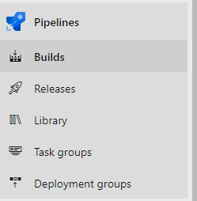

## Create new build pipeline

Build step will only copy and publish the artifacts

### Connect

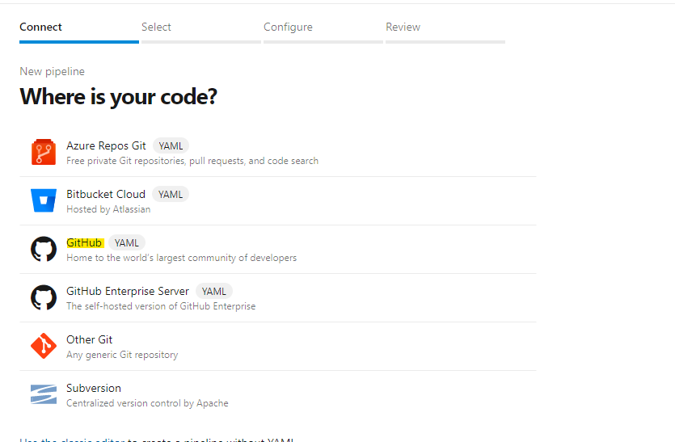

### Select your git-hub repo

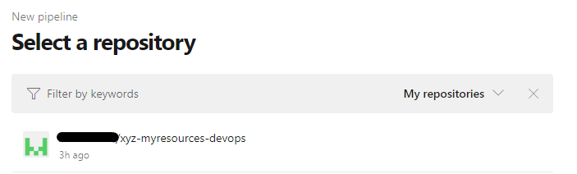

### Configure your pipeline



### Review and Save

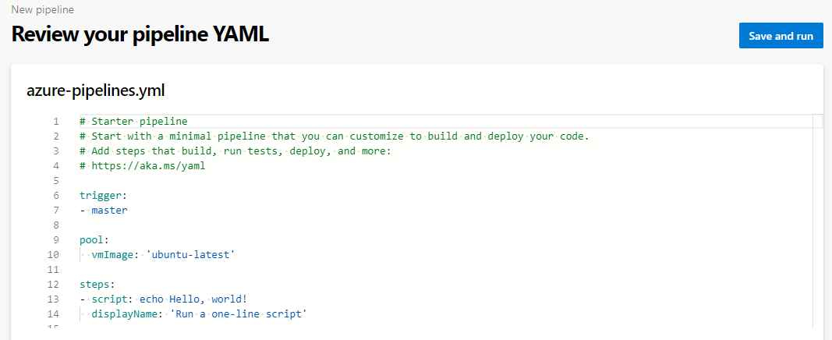

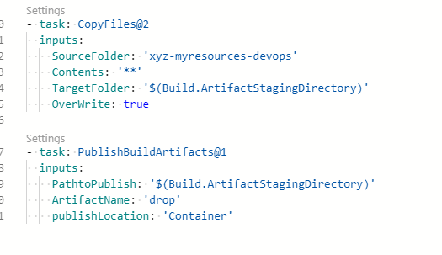

## Create Release pipeline

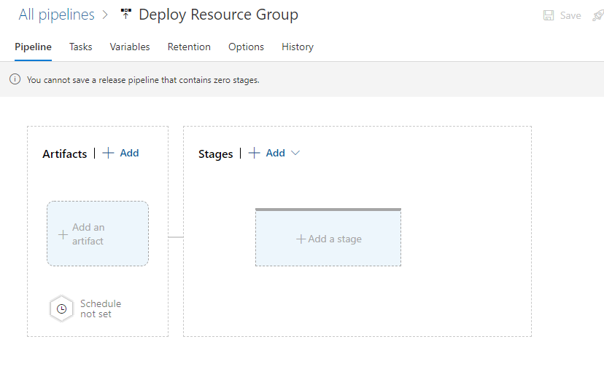

### Add an artifacts

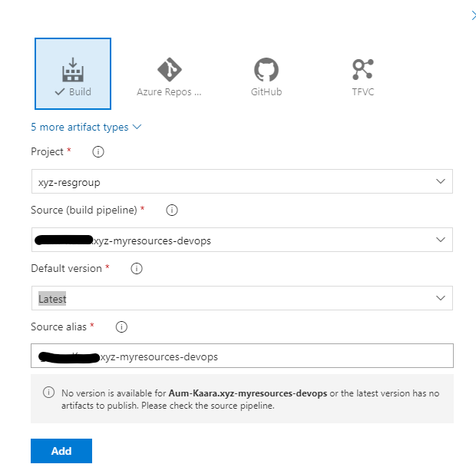

### Add a Stage to deploy changes

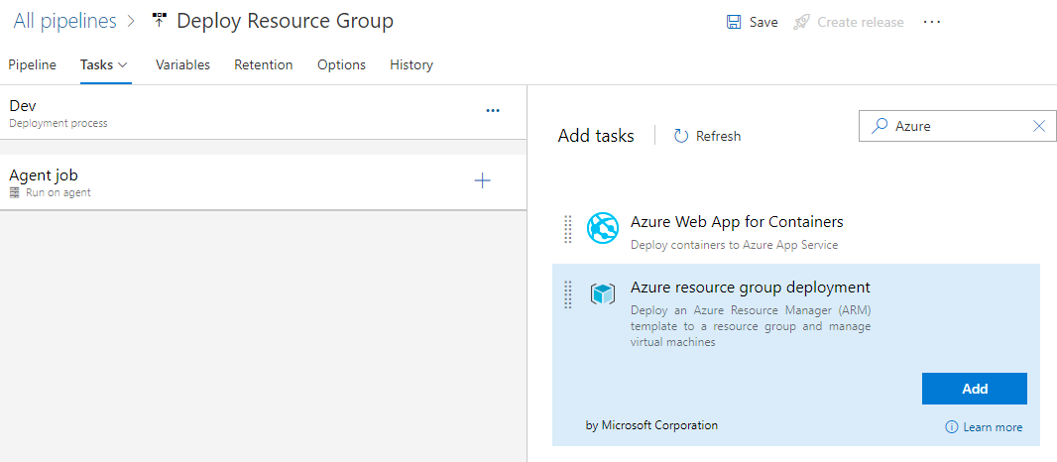

Configure Azure resource group deployment task

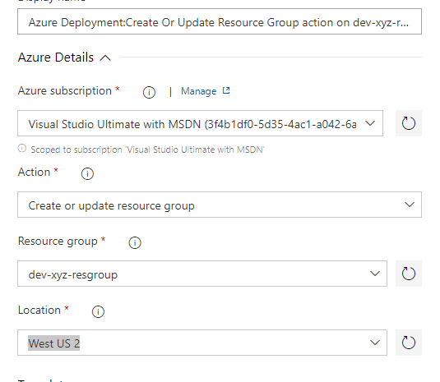

### Select ARM Template and Parameter file

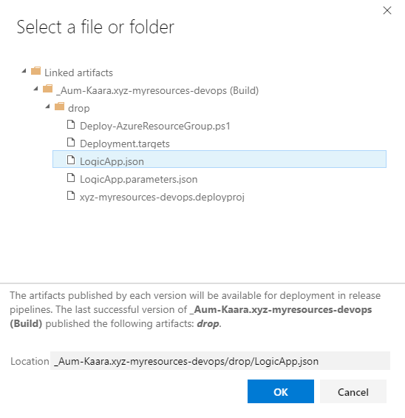

### Clone the same stage for Test environment deployment

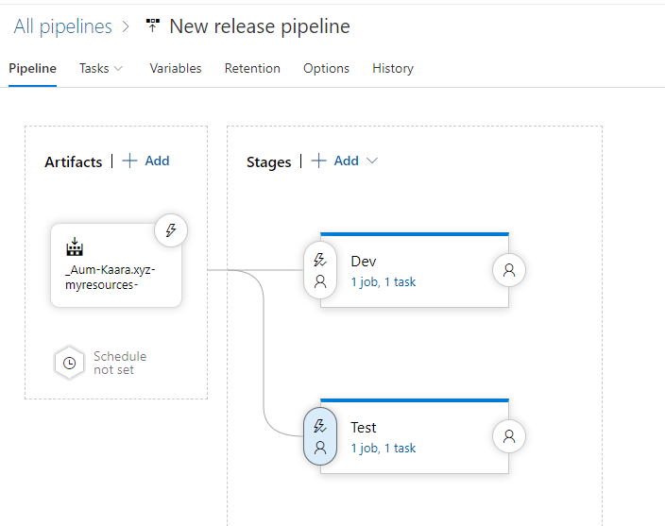

### Create variable for Release based on environment

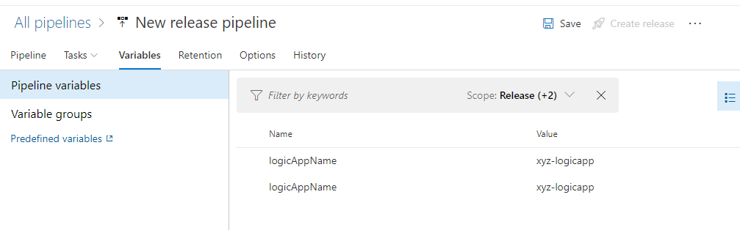

Create new release

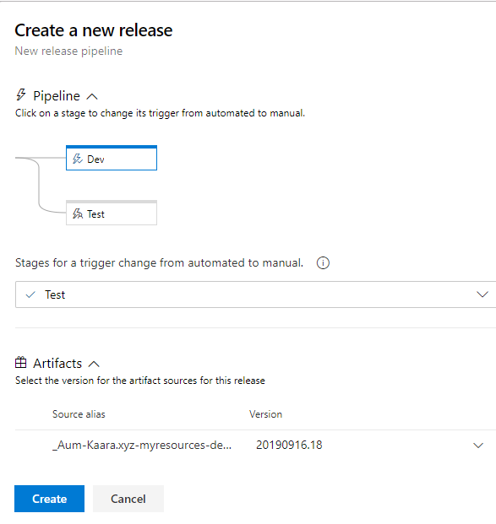

## Test Release

